**Web CA2 Site Structure:**

**By Aaron Gilmore**

**Intended Users:**

Everyone who has access to a device and can access the internet and who has an interest in movies.

Types: Currently only users but will be expanded to included members & administrators.

Administrators will be allowed modification privileges while members will be allowed comment in the comment boxes.

**Site navigation:**

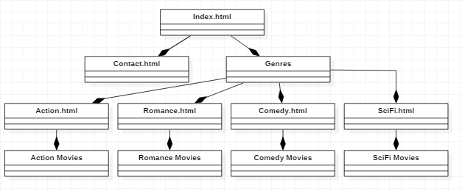

We designed the site so it flows downwards like a user would expect. We took inspiration from other sites such as IMDB but left out parts we found that wouldn’t be useful to general movie watchers as we thought it looked to intimidating and cluttered.

The Navigation is consistent on each page as each page has a nav bar that can easily transport users through the site and if a page is long enough so that the user must scroll down there is a back to top function that will bring the user back up to the nav bar with ease.